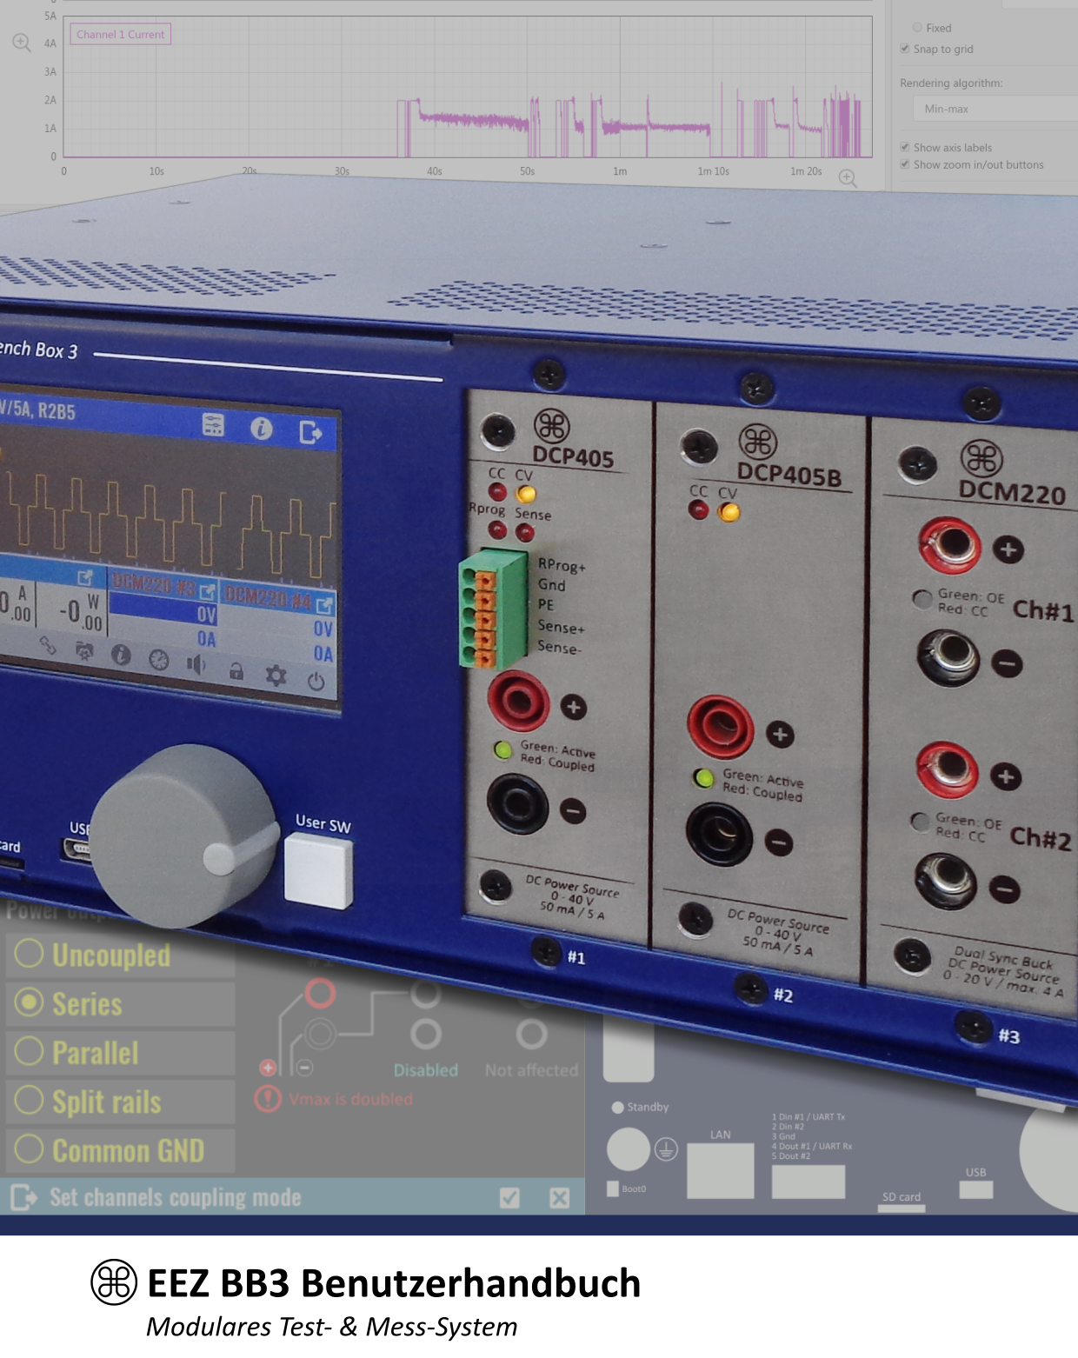
Ver. 1.04 – 02/2021
www.envox.hr – github.com/eez-open

